**Ex.No : 9**

**VIEW, INDEX, SEQUENCE**

1.Create a view with name ‘std_view’ using STUDENT table which holds the value of register number, name and DOB of student.

Ans)

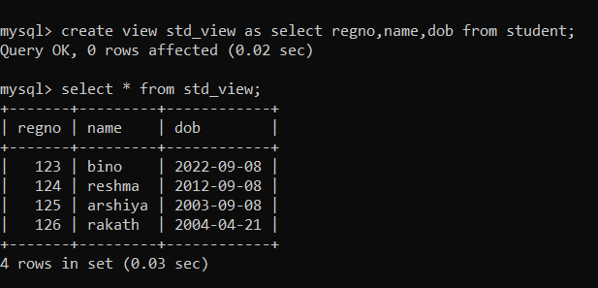

2,create an index on courseno of student and analyze the performance

Ans)

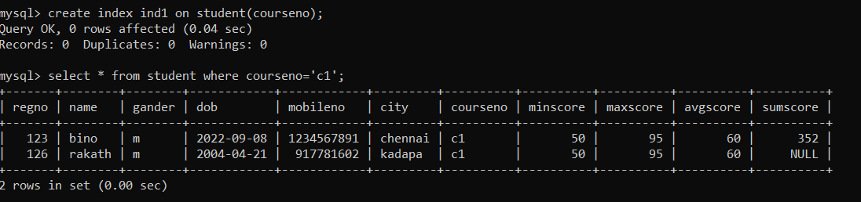

3.)EXPLAIN select * from student where courseno='c1'.

Ans)

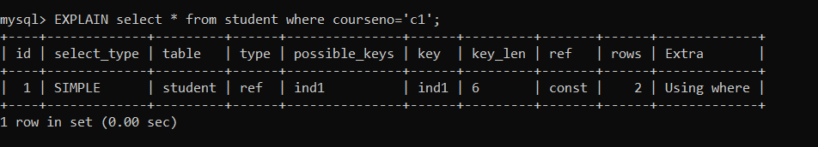

4.)Create a example sequence

Ans)

